Orchestra Assessment Preparation Session

ASTA March 8, 2019

Info on Mr. Trowbridge.

Trow’s Basic rules to remember for assessment

Preparing music for Assessment.

Selecting Music

Pre-Assessment Concert.

Sight Reading – preparation.

Breaking down 1st page of Brandenburg no. 5 Bach/Isaac Grade III score.

Assessment warm up piece - selection and preparation.

**Michael Trowbridge assessment background:**

33 years of teaching **31** years of assessment prep, music selection, sight-reading preparation. (Stafford County did not participate in orchestra Assessment when I taught there – my first two years of teaching).

Have earned I’s II’s and a couple of III’s at assessment.

Have done Orchestra assessment with students from grades 5 through 12.

I have made many mistakes along the way and also was blessed with many talented players, great feeder schools and supportive administrators.

In my first year a Godwin Middle School in the fall of 1978 I asked Dr. Bailey (supervisor of music at the time and Zuill Bailey’s father) to buy the orchestra program an electronic tuner. His reply was “if I get this tuner for you, you had better get a I at assessment!”

After a couple of years at Godwin, I took a full orchestra to assessment at Robinson Secondary School. We were grade IV and the only judge’s comment that I can remember was “How come the flutes are not using vibrato! “

**Some general statements about getting ready for assessment:**

**And who is this session intended audience**

Do not assume that your students will practice on their own at home. I never did. If you want these done you need to do them in class.

Prep for orchestra assessment is more then just learning music for assessment. It is about picking the right music. Having good intonation. Practicing sight-reading, good tone and good intonation all year long. Picking a reasonable warm up tune. And making your kids do it right. That last thing is the hardest thing to do.

The music that you play for assessment will most likely be different then the music that you will do on your fall, winter or spring concert. Assessment is not a time to try II position or the Key of F etc.

Even if all of your orchestra students can all spell Shostakovich it does not mean that they can play in tune.

Do not experiment at Assessment! “Experiment” at your spring concert! I used to “experiment” at the Virginia/NSOA orchestra assessment. We would play things that I would never do at assessment. The judges at NSOA were always university prof. three pieces that I remember were Shostakovich Polka from the golden age, Mahler adagio for strings and harp and Voyage for string orchestra by John Corigliano.

Who is this for: I had the opportunity to hear bunch of group at TMEA a few years ago. The comments I will be making are for “normal” folks with “normal” orchestras

**Trow’s Basic Rules for “Assessment”**

**Read the “rules”**

If you do not know the rules you can’t play the game.

**Check “the” list**

Make sure the piece that you are working on is on the “list”

**Buy Early**

Order your scores for assessment early! There have been years where I forgot to order a score(s) and had to call around to other orchestra directors to get enough scores. Most of the time I would order 3 scores as soon as I knew that we were going to play the piece for assessment. A bunch of bad “stuff” can happen to you if you show up with out scores or copied scores etc.

**Correct Arrangement?**

Make sure you are doing the correct arrangement of the piece. (There can be three or four arrangements of the same piece in some lists and you have a 5th one that is not on the list!) I know a teacher who played a piece for pre-assessment concert and then had to start another version of the piece and perform it 2 weeks later at assessment.

**The right fit for your orchestra**

Play the piece because it fits your orchestra.

If you pick music that your students cannot play, the orchestra will not be successful and it will not be the students’ fault. Been there and done that!

**Yeah… the kids like it, but…**

Do not play a piece for assessment only because the kids like it. Can they play it? Is it the best piece for them to play?

**I love this piece, but …**

Do not play a piece for assessment only because you like it. Guilty as charged! In a whining Luke Skywalker voice “But I always wanted to conduct… (fill in the blank)

**No Mozart**

Do not play Mozart at assessment! (I have done it and that is why I know not to do it.) Been there done that! It is like taking a bunch young kids with rocks in their pockets into a glass house

**No Mendelssohn String Symphonies**

Do not play any of the Mendelssohn String Symphonies for Assessment. Great music but **too** long and will **expose every part of your orchestra**. Been there done that!

**No Fugues**

Do not play a Fugue for assessment unless your group is very good. And every section of the orchestra in very strong. Been there and done that. Guilty as charged!

Lesson learned at Godwin Middle when my 6th grade orchestra tried to play Handel’s Little Fugue in G. Again Dr. Bailey’s words of wisdom: “If you ever do a fugue with a 6th grade orchestra again I will fire you” Or something like that.

**Not all year long**

Do not work on an assessment piece(s) all year long! Again just think if you were in that orchestra. How would you feel? Playing the same piece of music basically all year long?

**All year long**

Work on the things that you will need to do in your assessment piece all year long!

Work on pitch all year long not just from January to the beginning of March!

Make sure everyone is in tune. (instruments) Take time to get bass and cello section in tune. (This is something that should be happening all year not just a month before assessment) I have been guilty of being in such a rush to get a lot of stuff done during class that I would forget to let my class tune!

Every day orchestras are working on intonation. But don’t we seem to crank up the expectations during assessment season? We need to spend some time every day working **slowly** on intonation.

One example: if playing a piece with C# on G string have bass and cello play a drone “A” and have the rest of the orchestra play “A” with cello and bass and then have violins and violas move to “B” and then “C#” while cello and bass section are still playing “A**”** (this is something that sound be happening all year not just a month before assessment)

Another example of intonation work: have your best player play the note “A” on the G. Then one at a time each other player plays same note to see if they are matching pitch. (This is something that should be happening all year not just a month before assessment)

If you want your orchestra to play in the key of F at assessment they need to know it before January.

Same thing goes for shifting – vibrato – Third position – second position – Needs to be addressed in the beginning of the year!

**Trading places**

It is very important that every day and multiple times per class think how you would feel if you were a bass player in your class or a viola etc … makes you want to change up things and move things along. Not everyone in the class wants to spend 15 minutes getting that one chord in tune. They want to get it in tune – but most likely do not have the same feeling about that you do.

**The final say**

Do not let the students bully you into play what they want to play at assessment.

And as said earlier …

If you pick music that your students cannot play, the orchestra will not be successful and it will not be the students’ fault. Been there and done that!

**Not the time to “try” something “new”**

Do not play in key of F, Bb, Eb, A or E unless your orchestra is very good and your orchestra is very comfortable with those keys before winter break.

**Worth the time**

Is the piece that you pick musically worth the work that will have to go into it? (Why in the heck are we doing this piece?) Or - this piece is an ok piece but would have been great if it ended 5 min. ago.

**Don’t wait for the details**

If there is a crescendo do the crescendo the first day you play the piece. Do not wait four weeks into prep and then start reminding them to do all the details.

**Preparing music for Assessment**

**Start in September**

Lets Talk about Time in the class room! I am mentioning time because it very important to use time wisely not only when you are preparing for assessment but everyday of the school year. (Because that is when you are really getting ready for assessment)

99% of the time at GFHS there was one day of the year when we did not play … and that was the day after assessment … my kids hated me sometimes because we would play everyday. Even until the very last day - or as close to the last day that I could get.

There is a lot of time from the beginning of March until June 18 and lots of stuff can be learned during that time … of course it is tough if you have a lot of 12 graders …for 8th grade class try to have concert more toward very end of school Keeps everyone busy.

Try to have students that can lead the class if you are out at All state/ regionals etc. I had good and bad luck with that. the student that leads the class has to be looked up to and has to be patient with the class.

**“The Middle Section”**

Make sure that you start on the middle section of your Assessment music ASAP. Do not wait two or three weeks after working on the opening section to find out that there is no way your group can play the middle section.

Great story about D Trow at music assessment in Boston - middle section of Sinfonia in D by Stamitz

**Invite others in**

Invite the band and or choir director into your orchestra rehearsal so they can hear what is going on. It will give you another set of ears. (I was lucky for many years to work with very good band and choir directors who come over and listen to my orchestra all the time.)

**Recordings are you best friend**

Use a “tape recorder” and use it often. They do not lie. And you will hear exactly how your orchestra sounds. This is hard to do. been there and done that. Does not take any extra class time You just have to remember to bring in machine in and turn it on.

Make a “tape” of your rehearsal and share it with another orchestra or band director. Again, another way to get a different set of ears to help you. (Years of watching Dennis Brown, Mark Carder and other do this. Melinda McKenzie Hall, former band director at GFHS and Woodson HS now at Bishop Ireton, recorded her band almost every day during “Assessment season”)

**One position extended scales**

Funny how we have the students practice a one octave scale in 1st position - but the notes we need to play the piece range from the open G to 4th finger B on the E (for the Violin)

Make sure that your orchestra practices “extended scales in position” in the key that your piece is in. (for example: Violin in the key of D would be all the notes in the D major scale on all the strings in first position – start on open D play one octave up and keep going to 4th finger on E. Start back down and keep going below open D to C#, B, A, and G on G string and then come back up and end on open D.

**Share the music**

Hand out 2nd violin music to the 1st violins (in addition to 1st violin parts) So that the 1st violins can assist 2nd violins in learning part. Also the other way around one day those 2nd violins will need to be 1st violins.

**Move ‘em around**

Have your best couple of 1st violins move to 2nd violins section for a day or even a few minutes to have them help 2nds. This is great if you have a couple of REAL good player and everyone else is “OK” the good ones will really feel like they are helping the orchestra. You have to approach it the right way and do not keep them there long.

Have all 2nds violins sit with a 1st violin and go through the 2nd violin part. This idea will help the 1st violins with sight-reading… might not be a good idea to turn it around and have every one play 1st violin … 2nd violins will realize that they have a boring 2nd part (if they indeed do have a boring part)

**Turn things around**

After the second and first violins have been working on parts for a while have them turn around so that they are all facing to the back of the room and run through the music. The students will not be able to rely on watching the first stand for entrances, bowings, etc. This really help ensemble playing, they have to listen and count. You can even mix up the whole orchestra and mix 1st violin stand in vla section etc. And if you have enough stands each kid mixed the middle of everyone else, as if the whole orchestra has been put in a blender!

**Send your 1st chairs “out”**

Send your 1st chairs “out” to work on chamber music during class. (The chamber music can be assessment music) the key is that everyone else will have to step up to get the work done. Lots of ideas for getting the first chairs out of the room… sometimes however there is no place for the kids to go.(no practice room … hallway sometime does not work. I even had the idea to have a guidance counselor meet with my best violinist so that “I” was not “taking her out of the room”.

**After school**

Ifyou **must** have after school rehearsals, you have picked the wrong music for your orchestra. Obviously, if you need to put two classes together, then you will need to rehearse after school. Or maybe you need to work with cellos once or twice. And of course if you are doing full orchestra.

**Help the bass player**

If your bass players have their parts learned give them the cello part to play (if possible). It will keep them from going crazy and keep them from misbehaving. Other ideas 1. If they know the part do not use open strings, or try to play on one string, or do not use the G string. Make it challenging but stress to them that in the concert (assessment) it has to sound the best … even if you have to go back and play it in “1st position.

**Keep it short**

When testing assessment (or any music at any time) music in class keep tested section short. Can be as short as two notes – to hear if they are getting an interval correct. Or a shift in tune. Or a couple of measures. You do not want to spend all of your time testing music for assessment you need to spend your time working on music for assessment.

You can also hear quartets or quintets play sections of assessment music. More testing done in a faster amount of time.

Also testing by section of orchestra

If you tell the kids that there is a test on letter A to letter B the only thing that they will practice is from letter A to letter B. The piece will not sound good anywhere but from letter A to B. They need to know the whole piece. Teach them early to be responsible students - hard to do.

One idea for learning a part is what I call “elimination” start with all 1st violins standing and playing the section in question. Move around in the section and the student(s) that you hear playing the section correctly get eliminated and get to sit down. The students will be playing the sections many times and will be getting better each time. No one wants to be the last man standing. (I think this works better at MS then at HS. At high school I used to just go stand by stand, no grade, They will feel bad enough if they do not know the music. I never saw my HS kids practice as hard as they did for seating auditions. Sometimes tests do not motivate them.

Use a metronome to make sure you are working on same performance tempo with each class (if combining classes for assessment)

**Why did you play**

Be careful not to get bogged down in spending all your time on nitpicking. Students joined orchestra to play – not to sit around while you work with the 2nd violins. Think of way to get the job done but keep everyone playing. This is one of the hardest things about being an orchestra teacher!

Think of how you would feel if you were sitting in the orchestra doing nothing while your teacher worked with the same kids over and over again. This has helped me many times!

**Selecting Music For Assessment**

**Started years ago**

Did you go to assessment in Middle school and or High school? What did you learn from that? We all learn what works and what does not work while watching others. What worked and what did not work?

**Read the comments**

What did your rating sheets say?

Did they say the same things the year before?

What rating did you get?

**Break it down**

Did you pick good music?

Did you pick music that fits your group?

Did your orchestra play in tune?

Did your orchestra play musically?

Did your orchestra play with dynamics?

Was the music too hard for the students?

Did you start to work on your music too late?

Did you pick your music too late or have to change a piece because of a miscalculation in student’s ability or your ability to teach it?

Did you start to work on it too early and students lost interest?

Peak too early? (a phrase used a lot in the band world)

If you are a new orchestra teacher at a school you need to do the following:

Get list of music that has been played by your group in the last four years or so.

Hopefully the teacher that just left has assessment ratings and sheets from previous years.

Make sure to read over previous years rating sheets - No sense in making the same mistakes that they made.

**Middle Section**

When selecting music for assessment make sure your orchestra will be able to do the middle section of the piece. – You know, the section that will have:

A minor section

Accidentals

New key(s)

Different tempo

Slower tempo (young players have a hard time with slower tempo sections.

New thematic material!

**Music selection form**

|  |  |
| --- | --- |
| Name of Piece |  |
| Grade Level |  |
| Key |  |
| Time signature |  |
| Key of “B” Section or middle section |  |
| Tempo |  |
| Block chord Voicing |  |
| Independent Voicing |  |
| Position work for Violin, Viola Cello, Bass (circle) |  |
| Overall Rhythmic Difficulty |  |
| Dotted notes |  |
| 16th notes |  |
| Which orchestra section has easiest part |  |
| Which orchestra section has hardest part |  |
| Repeats, DC al Fine etc |  |
| Length of piece |  |
| Accidentals |  | |
| Shifting in bass part? |  | |
| Viola and 2nd violin parts deathly dull? |  | |
|  |  | |
|  |  | |
|  |  | |
|  |  | |
|  |  | |
|  |  | |
|  |  | |
|  |  | |
|  |  | |
|  |  | |
|  |  | |
|  |  | |

**Pre-Assessment Concert.**

**The best prep**

If you do not have your orchestra play a Pre-Assessment Concert you need to. Many valuable things can be learned from doing a pre-assessment concert

**Two weeks**

A concert two weeks before assessment is a great way to motivate everyone to work harder.

**Fix it**

Then you can refine the orchestra for two weeks after Pre-Assessment concert

**Get on stage**

The more your orchestra plays on stage the more comfortable they will feel playing on stage. Will need to do it often – not just at the Pre-assessment concert

**Invite your friends**

Having Pre-Assessment with other schools (feeder schools) gives a feeling of what assessment will really be like.

**Get an adjudicator(s)**

Try to have an adjudicator(s) to listen to the groups. All groups will need to bring scores.

**Sight Reading**

**Read the rules**

One of them might be: Most likely 5th grade at assessment will be grade I and grade I does not sight read!

Can they touch their instruments, can they sing? Can they air bow? Can they start over? Etc.

**Please remember that you need to sight read all year long!**

Prep for sight-reading needs to go on all year long – Starting with the first time you play on the first day of class in September.

**Talk through the piece**

You should take some time to talk about what is going to be happening in the piece.

* + - The basics are:
      * Key
      * Tempo
      * Tempo changes
      * 1st and 2nd endings – road map stuff.
      * Accidentals
      * Shifting
      * Dynamics
      * Are there repeated rhythms
      * Are there dotted rhythms
      * Phrasing

**Students chip in**

Have all students look at the piece and find all the “interesting” things that we need to know about 30 pairs of eyes are better than one.

**Practice the routine**

You might not cover every one of these things every time you sight read in class.

There might be a couple of times where you just hand out music and play it. With out saying anything about the piece before playing it.

But you will need to cover the entire above list and more while you are in the sight-reading room at Assessment.

The more you, as a teacher, practice sight reading with your orchestra the better you will be at guiding your orchestra though sight reading at Assessment.

**“A Treasury of Scales”**

Use “a Treasury of Scales” to improve intonation and most importantly awareness of keys.

Start with just playing the first Chord. Major or minor what key who has the 3rd who has the root etc etc.

**Rhythm Books**

Use “A Rhythm a Day” and other similar books to prepare for sight-reading. We could talk for hours about the many ways we could use these books.

**Method books**

Use method books to practice sight reading.

**Move ‘em around**

You can move your students around into different sections for sight-reading at assessment.

For example: move a couple of strong readers from 1st to 2nd violin. (Might be a good idea to practice doing this in the classroom before hand)

**Cue your students**

Being able to cue your students when they are sight-reading can be a great help to the orchestra.

Beware of using cues too much all the time. The students will get lazy and not count. Sometimes the only counting that they will be doing is counting on you to let them know when to come in.

**Please remember that you need to sight read all year long!**

Starting the sight reading procedure 2 weeks before assessment will not cut it.

Interesting sight reading stories:

One year the GF Concert orchestra was told to get the sight reading piece out of the folder in the sight reading room my students eyes were wide with surprise, we had played the piece for our winter orchestra concert! Since there is only one sight reading piece per grade we sight read the piece we had already played in a concert.

The above is a case where I ordered “new” music and VBDOA gets sight-reading list from “new” music.

One year the GF Chamber orchestra had to sight read a piece that we had just worked on for sight reading the week before Assessment!

The above is a case where a “old” piece was re-released years later and listed as a “new” piece.

The last and most important story from a sight reading experience: One year my concert orchestra was grade VI on stage and got all I’s from the judges. Then we went to sight-reading. We did a good job sight-reading. However the sight-reading judge was not impressed with my lack of control of my students in this particular class (mostly bass section) and we earned a III in sight reading. That story was told to many of my orchestras since that assessment.

**Please remember that you need to sight read all year.**

**Breaking down Bach Brandenburg No. 5 arranged by Isaac**

What a “new” teacher sees when thinking about doing this piece for Assessment.

In the beginning of January after winter break

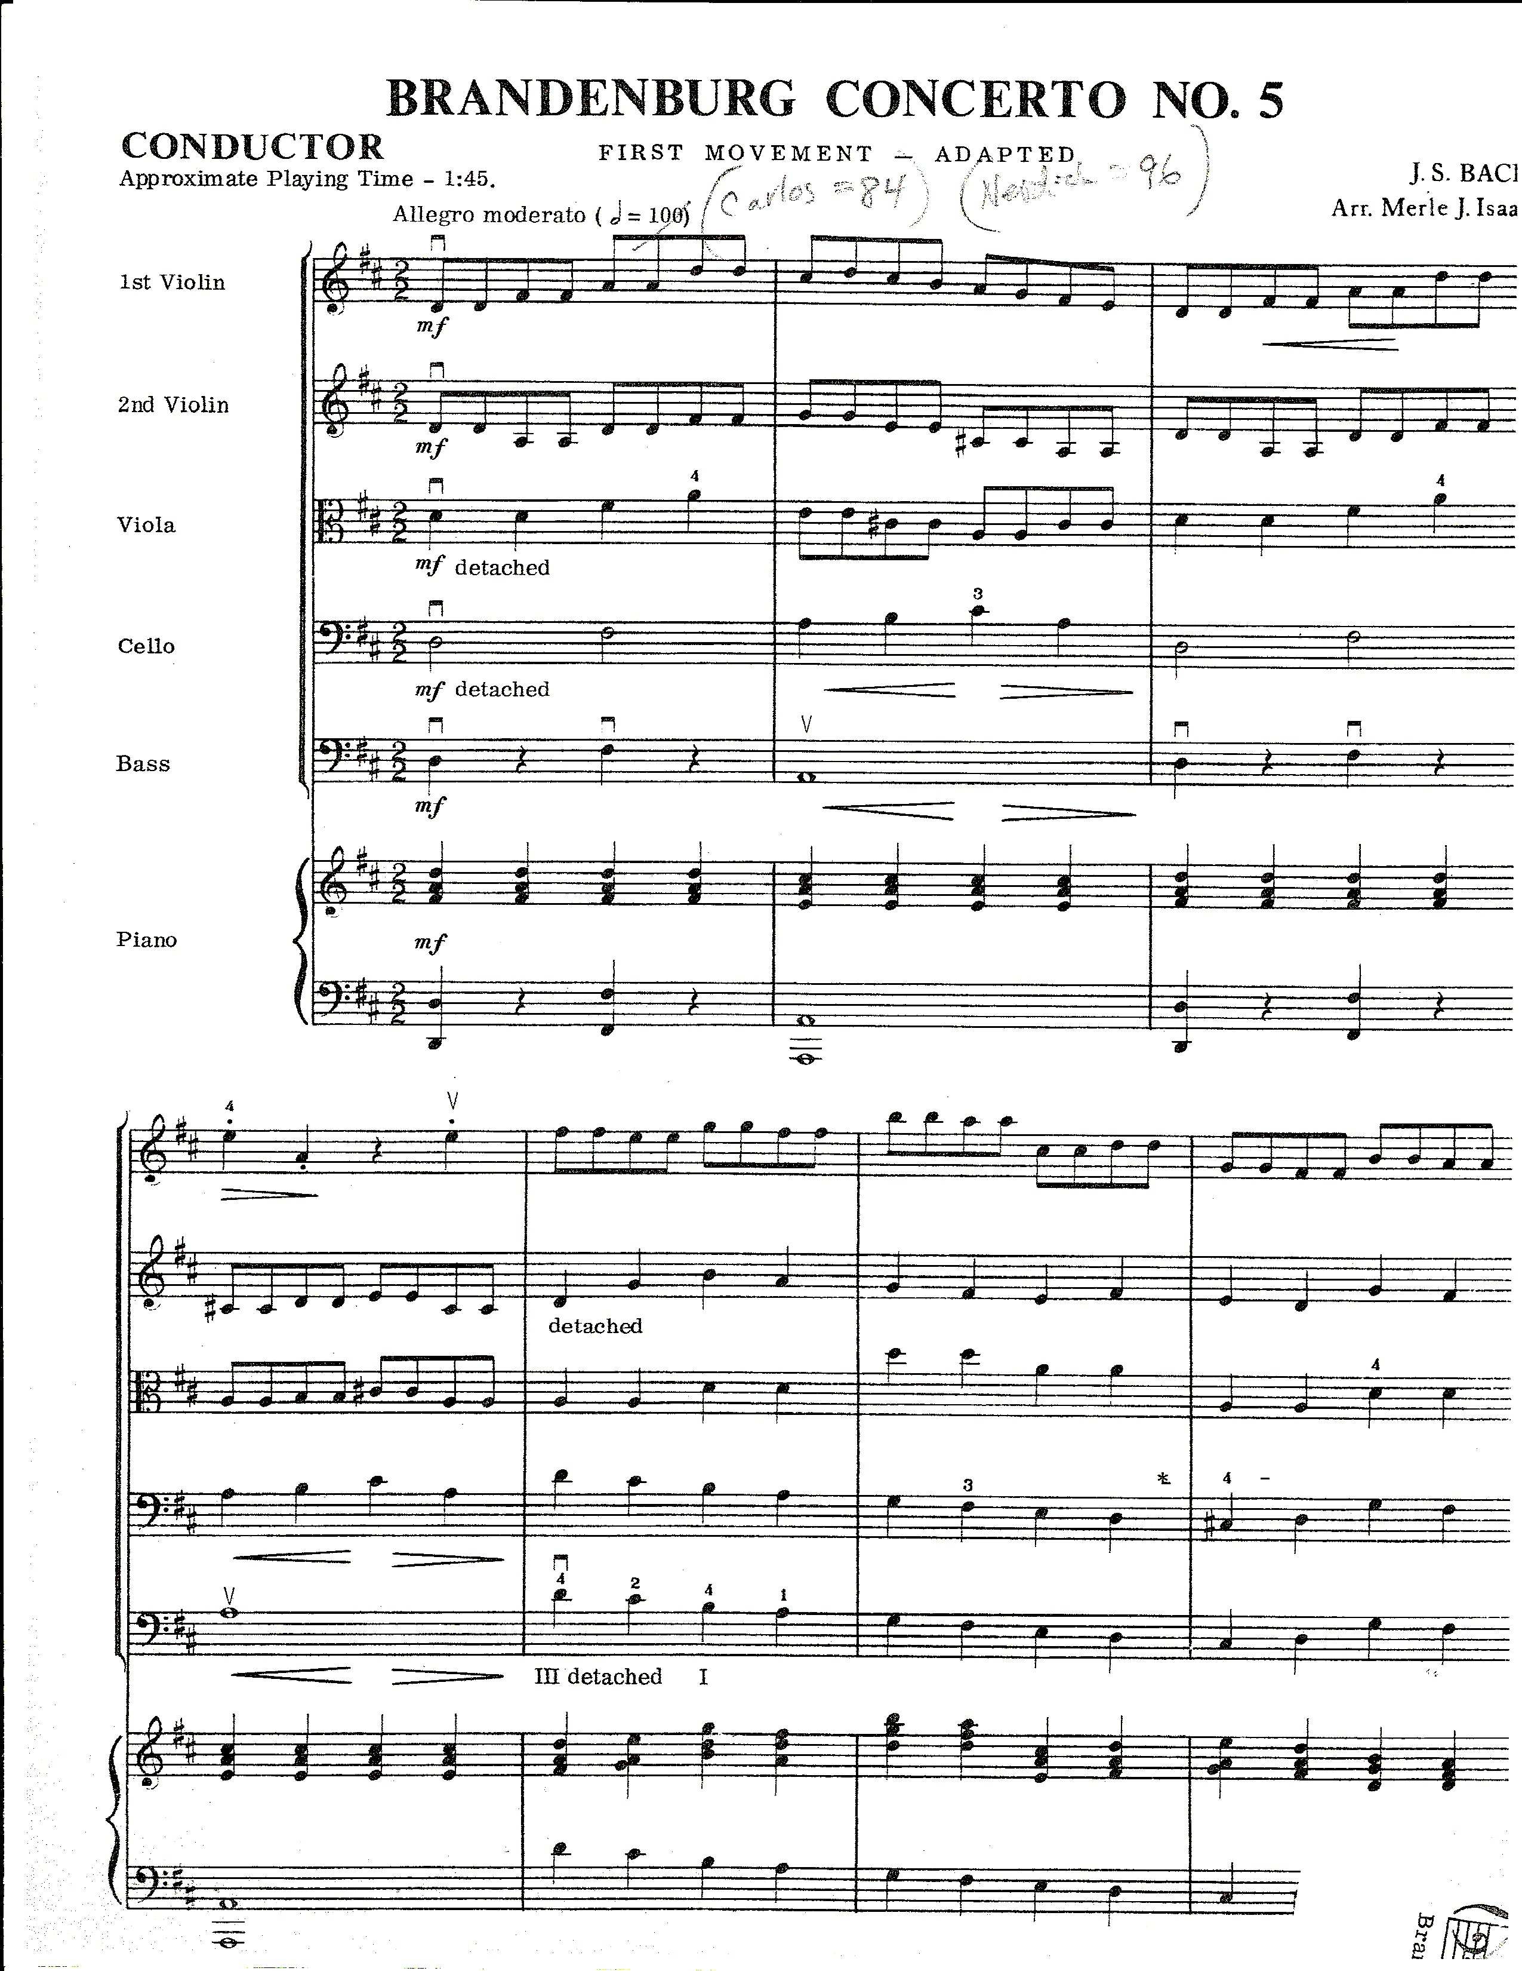

**What a Assessment adjudicator “sees” when about to**

**Hear an orchestra play this piece!**

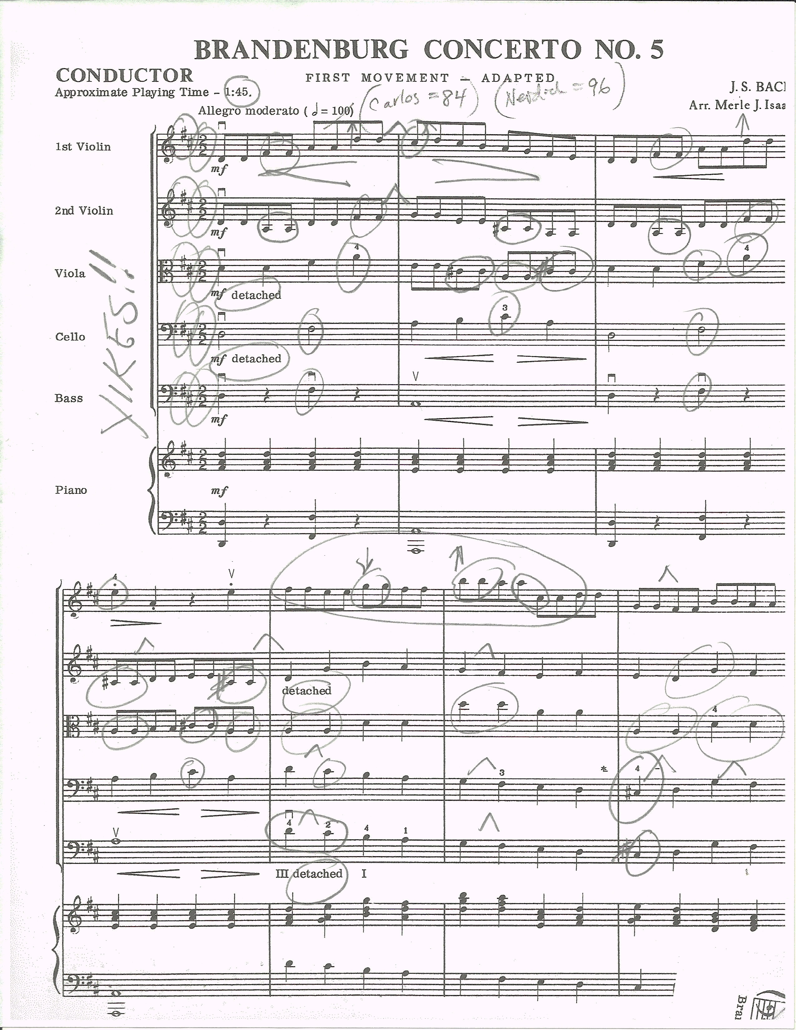

**Technique/knowledge needed to rehearse Brandenburg No. 5 for Assessment**

Remember we are only talking about the 1 page of the score!

Can the orchestra play in 2/2 - Cut time?

Does the orchestra know what those 2 sharps really mean?

Can the orchestra play D major arpeggios in tune? Can start this in 5th or 6th grade.

Can they play a D major scale in tune? Can start this in 5th or 6th grade.

Can they play a D chord in tune – The second beat of the piece? Your dreams of getting a superior rating could be over by the 3rd beat of the piece. Can start this in 5th or 6th grade.

Can all of the violins and violas use 4th fingers in tune? Can start this in 5th or 6th grade.

Do all of the 2nds, violas and celli have a good sense of pitch for the low A on the G-string? Can start this in 5th or 6th grade.

Can your basses play a one octave D major scale shifting up to III position? Can start this in 5th or 6th grade.

Can all of your students play the extended D major scale in 1st position?

That will cover low second finger on the E string for violins

Also 4th finger for violins on the E string.

The low A on the G-string for violins, viola, and cello.

The B and C# on the G-string for violin, viola and cello.

Extension for cello to get that C# on the G-string.

Have you trained your orchestra to crescendo when musical line moves up and decrescendo when musical line descends? (Measures 1 and 2) Can start this in 5th or 6th grade.

Can your orchestra play together – As in 8th notes, quarter notes, and half notes going on at the same time? Can start this in 5th or 6th grade.

Can your orchestra play 8th notes in cut time at half notes equals 100?

To recap The main problems when playing the first page of this piece

C# for violin, viola and cello on G string

4th fingers for violin and viola

G natural on E string for violins

General intonation problems

Rhythmic precision

Most violins and viola not used to playing on the G string let alone with C# needing to be in tune on the G string

Speed of the piece

**The warm up**

I my opinion the warm up is most likely the most important thing you will play at Assessment.

Keepthe warm up short and sounding great!

The warm up needs to be successful!

The warm up needs to sound good!

**Comfortable**

The warm up needs to make your students feel comfortable – get used to the stage.

**Done after the first note**

The adjudicators will have an idea of how well you are going to play after you play your first note.

It is the first thing that the judges will judge you by. If your orchestra cannot play a C sharp on the G-string in tune during the warm up they will not play it in tune in any other piece.

I have adjudicated many assessments where the orchestra’s warm up was harder and longer then any of the assessment pieces!

Some teachers think that because the warm up can be any piece of music and (in the past) was not graded by the judges that they could pick a piece that was really cool! But the orchestra could not play it as well as the other assessment pieces that they had prepared.

Even in the past when the “warm up” was not graded, it was always influencing the judges’ impression of the group.

**Bach**

Doing a chorale for warm up.

Short piece

Easy to play

Can focus on tone

Can focus on pitch

Can incorporate Vibrato

Can incorporate position work (ie III position for violins)

16 Chorales by J.S. Bach. arr. Mayhew Lake - G. Schirmer, Inc

Bach and Before for Strings by David Newell – Kjos Music

Chorales in Essential Technique 2000 for Strings

You can arrange your own chorale from J.S. Bach 371 Four-Part Chorales.

**Focus on tone and pitch**

Let them know you can play with a warm sound and play in tune.

**Shorter piece**

Takes some of the stress off of students. (and you)

Takes less time to prepare

Again if you have a very advanced group you can play pretty much what ever you like.

**Less time**

A short piece takes less time to prepare. More time can be spent on making it sound even better. Or working on the other harder pieces.

**Last thoughts**

**Use the entire year to prep**

**Use recordings**

**Kids want to play**

**Don’t worry ……. It’s only assessment**